DeepPV

# Introduction

Solar energy is a major sector when it comes to the Swedish energy market and is widely being adopted around the whole world to achieve a more sustainable future. According to Energimyndigheten, it has become very popular for residential solar systems, since both the technology is getting better and prices for installation lower. Many people install distributed solar photovoltaic (PV) on their rooftops, which are usually small systems that are decentralized from the Swedish governments system, see Figure 1. However, it has become hard to estimate how much and where solar energy facilities have been installed.

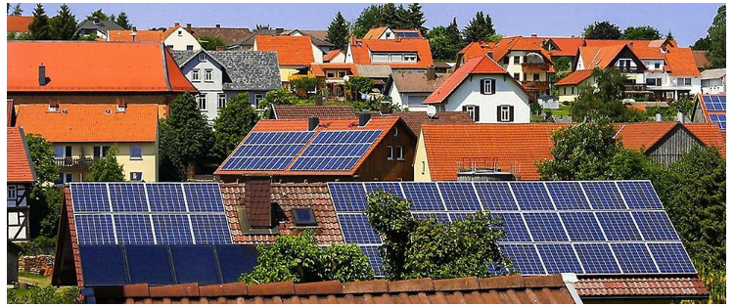

Figure 1, solar panel on different houses in Sweden.

This project aims to evaluate whether it is possible to determine where the solar systems are installed by using aerial imagery that simulates an existing drone that has a camera. Furthermore, to evaluate the state-of-the-art model YoloV4 for custom object detection of videos and images showing drone footage of house rooftops by comparing two models (performance: model 2 > model 1).

# Method

In order to localizes and classify solar panels an object detection model is needed. For this project the famous model You Only Look Once (version 4), YoloV4 was used. Yolo is a CNN-based object detector algorithm that is incredibly fast and accurate (Bochkovskiy, 2020). It can process over 45 framer per second from videos or take entire images in a single instance and predict bounding boxes coordinates and class probabilities around objects of interest, which made it a very suitable fit to use for the project. Furthermore, the network for YoloV4 has already been pre-trained with Microsoft´s COCO dataset which contains images with 80 different object categories (Lin, 2015). However, the COCO -dataset didn´t contain any object categories of solar panel. This meant that the first and most important step to solve this problem was to collect a lot of data of images of solar panels on rooftops. Google Images were the main source for data and could be collected with the help of using webcrawler-scripts. During the data collection, around 900 images of random sampled images of solar panels was collected. For model 1 the dataset was split into 85/15-ratio for train and validation datasets. The train dataset was than later extended for model 2 by 200 more images through data collection and 700 images from data augmentation. Both models had the same validation dataset.

## The dataset

Creating a high-quality dataset is crucial part of building object detection systems. Once the data was used Labelimg, a graphical image annotation tool, was used to create the bounding boxes and labeled data in YOLO text file format for the YoloV4 model.

When labeling images, there were a few labeling strategies to consider, see Figure 2. All solar panels were labelled with rectangular boxes tightly mirroring the object and some cases included non-object buffer (than excluding portions of the objects). Occluded solar panel was labelled entirely, i.e. if an object is out of view, it was labelled as if it could be seen entirely. Objects that were partially out of frame were also labelled in most cases.

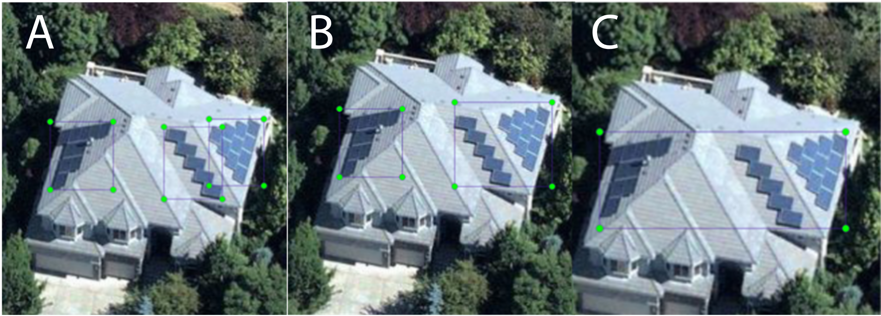

Figure 2, Illustration of varying labeling strategies.

The collected images of solar panels on rooftops came in general as groups and had various of different sizes and shapes. Option A from Figure 3 was the default strategy for labelling rooftops with multi slopes and solar panel groups. Basically, if a group of solar panels were on different slopes of a multi sloped rooftop and not joined, than each discontinuity of the solar panels was categorized as a new group solar panels with different bounding boxes, see Figure 3. However, if there were only one slope present with discontinuity for groups of solar panels, then the strategy was to merge the bounding box of the solar panels if one of these two rules were followed:

1. Each solar panel is within a range of the measurement of the average solar panel on the rooftop, see left image of Figure 3.
2. All solar panels on the same topological height (z-axis).

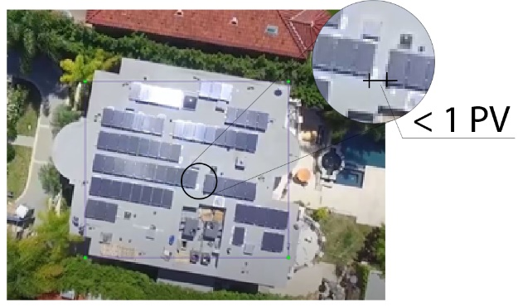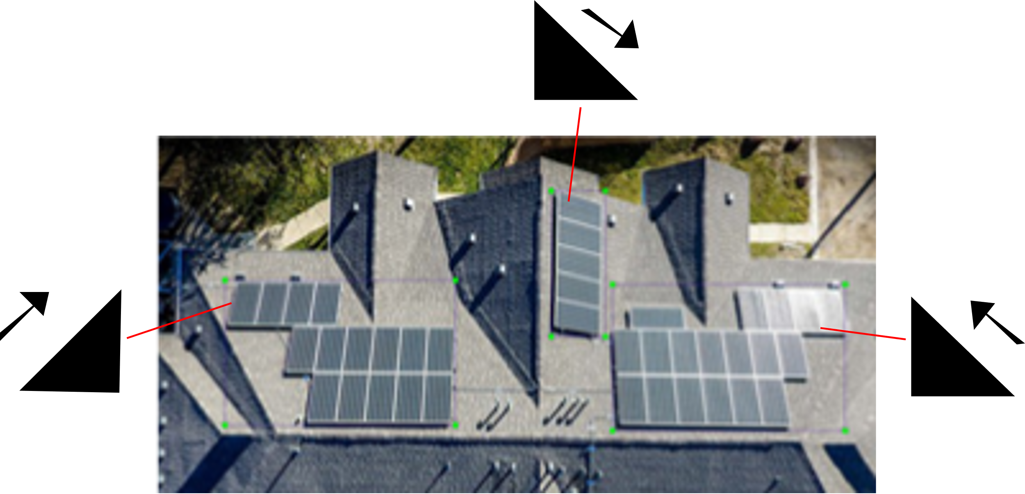

Figure 3, left images illustrate the slope strategy and left image illustrates the range of acceptance for grouping solar panels.

Data augmentation was used to create new training examples out of existing training data. Yolov4 has three different image augmentation settings by default, adjustment of saturation, hue and exposure, were all of them are used automatically in the training pipeline for the YoloV4-model. However, rotational augmentation was also used as pre-processing step for images that where shoot from angle between 75-105 degrees (90 degrees = perpendicular to the ground), see Figure 4.

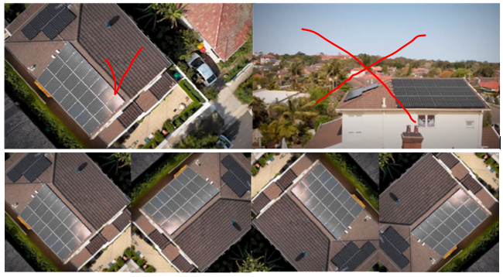

Figure 4, Upper left image shows a image that was approved for rotational augmentation. The upper right image was not augmented, since it could perhaps confuse the network.

## Model

For object detection tasks, precision and recall is determined by the intersection over union (IoU) value for a given IoU threshold (Bochkovskiy, 2020). Basically, IoU calculates the intersection over union of the actual bounding box and the predicted bonding box, which must be greater than 0.5 to conclude that it is acceptable prediction. However, for YoloV4 the mean Average Precision (mAP) was used as an evaluation metric to determine the quality of the model, were mAP is the mean of overall IoU thresholds. Non-max suppression (nms) was also used as a filtering technique to clean up detected objects that been detected multiple times in a single instance by taking the highest probability of the bounding boxes that associates to detected object. Furthermore, YoloV4 uses sum-squared error between the predictions and the ground truth to calculate the loss. The loss function is composed by three different loss functions, which are classification loss, localization loss and confidence loss.

Regarding the model configurations the pre-trained weights yolov4.conv.137 was used to speed up the training process, which is from the Alexy Bochkovskiy´s darknet implementation (https://github.com/AlexeyAB/darknet). Most of the hyperparameters for the model was configurated after Alexy Bochkovskiy´s recommendations:

* Batch_size = 64 and subdivision = 16, which ensure parallell computing power of x4.
* Max_batches = 6000. It should be set to classes x 2000 and not less than the training images, but not less than 6000.
* Steps = 4800, 5400. Step size must be set to 80% and 90% of Max_batches.
* Image width = 416, Image height= 416. The network image size must be a multiple of 32.
* Classes = 1, since there is only 1 class, solar panels.
* The output filters = 18. Each filter before the yolo-layers were set to filters= (classes + 5) x 3. This means that if classes = 1, then filters = 18.
* Confidence Threshold > 0.5. This means that bounding boxes will only be displayed on the images if the model´s prediction has a confidence score over 50%.

# Results

Figure 5 shows the results from the training model 1, left learning curve, and the model 2, right learning curve. Model 1 was overfitting, since the accuracy starts to drop around 2500-3000 iterations. Model 1 got a max mAP 67% from the validation dataset. Model 2 had more training data and was the attempt to improve the robustness and accuracy of model. Initially the train dataset was set to 900 images. However, data augmentation was used to improve the performance of the model without needing to collect additional data. This helped the model to learn what an object generally looks like rather than having it memorize the specific way objects appear in our training data, i.e. help to combat potential overfitting. However, it got a lower max mAP score of 58.5%, which means that robustness came at the cost of accuracy.

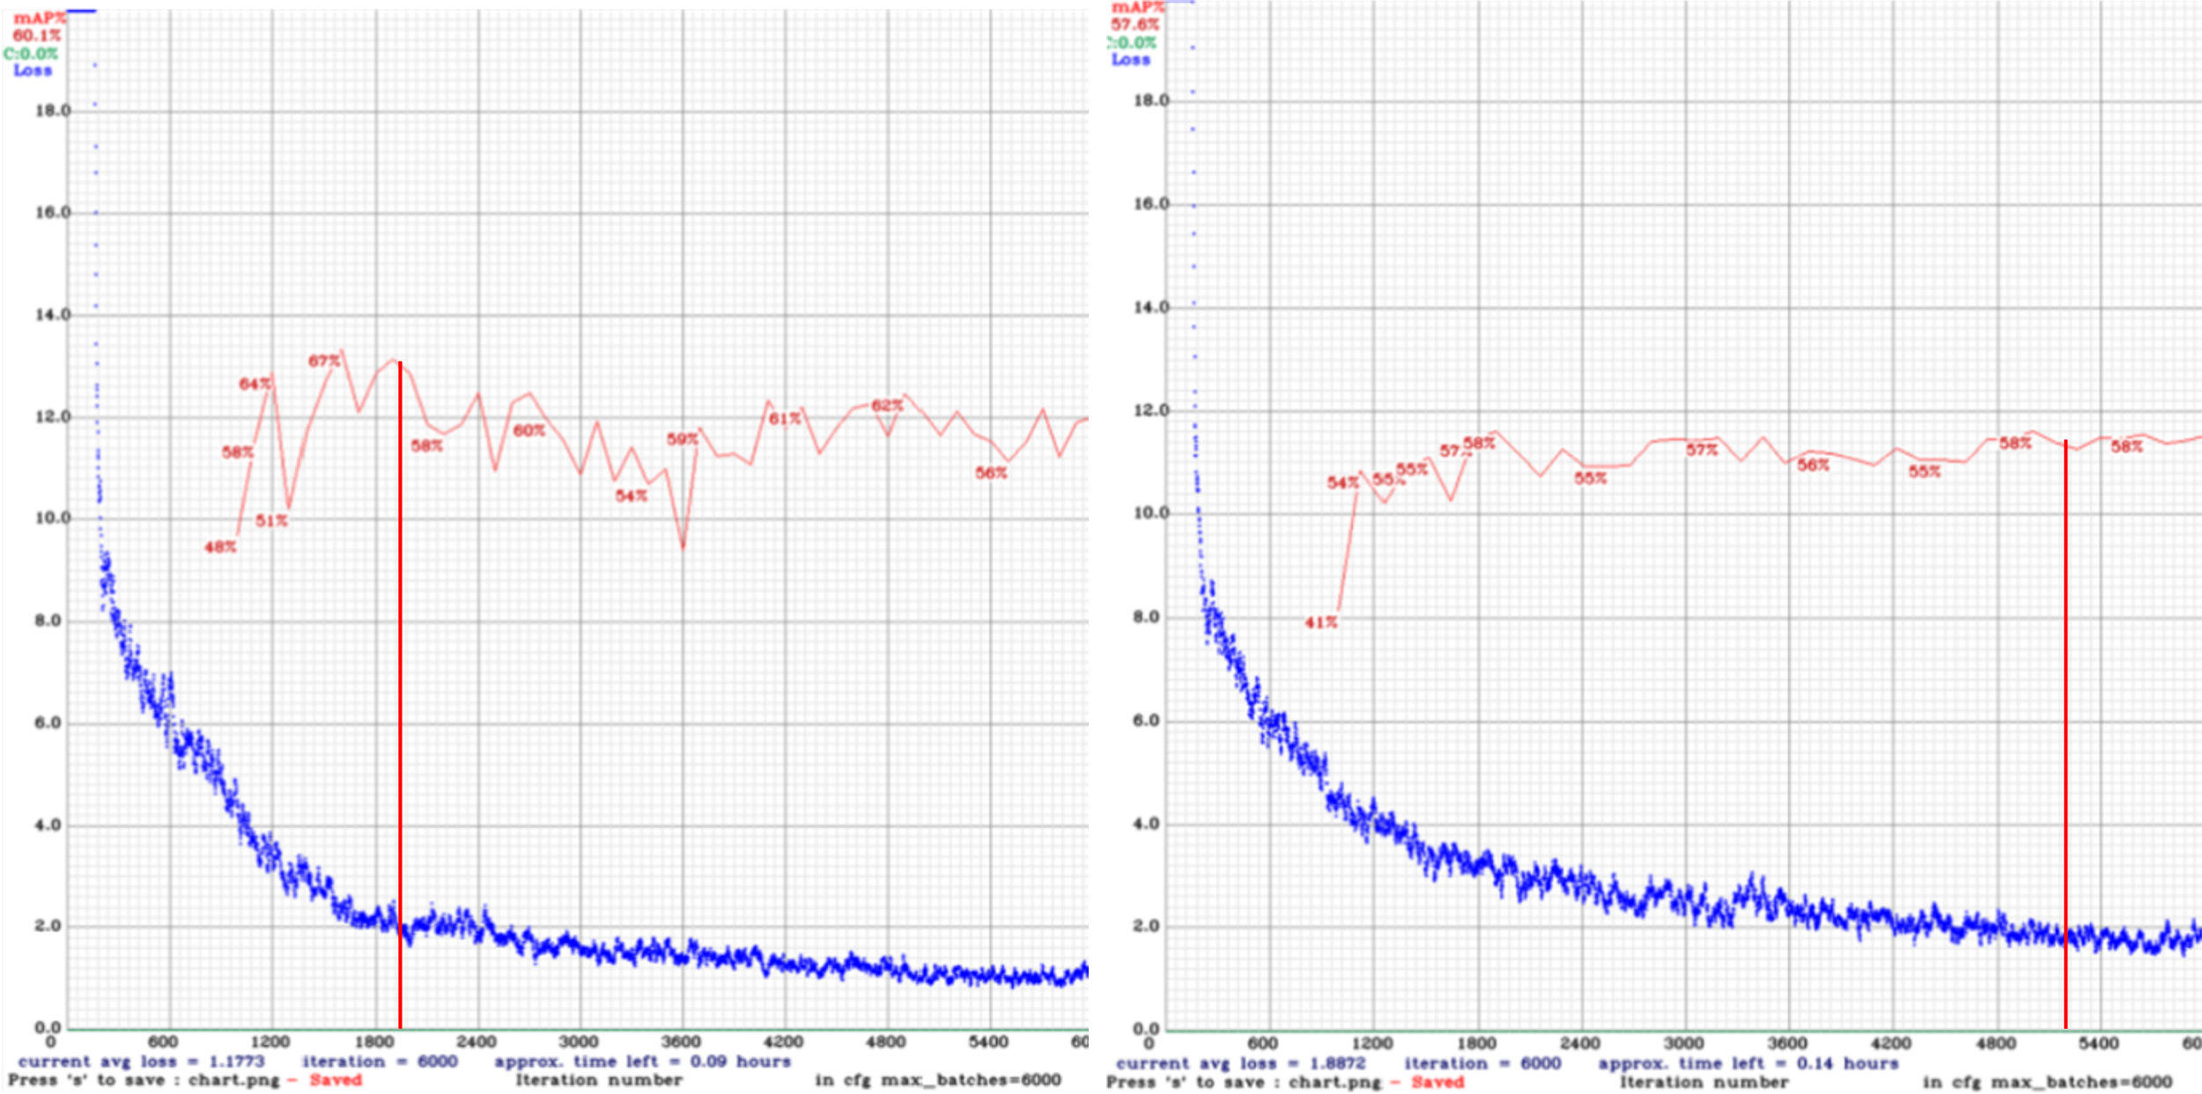

Figure 5, the left graph is from the training of model 1 and the right graph from model 2.

According to Alexey Bochkovskiy, it is recommended to have minimum loss below 2. This meant that the weights for model 1 was chosen at 2000 iteration and model 2 was chosen to have weights around 5000. When testing the models for test samples both models yielded the same results for most of drone images taken from an upper-side perspective when the position of shape of the solar panels was relativity obvious, see Figure 6.

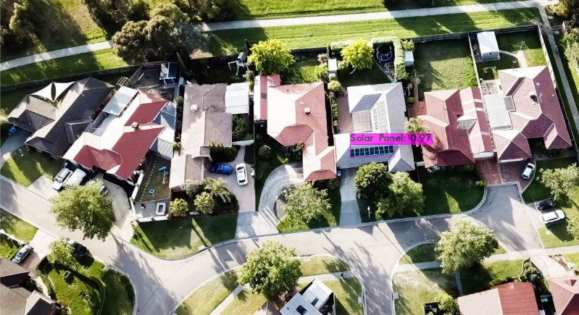

Figure 6, solar panel detection of a drone footage from an upper-side perspective.

For images with darkened roof areas, dark chimneys, chimneys shadows or even rooftop windows both models performed poorly, see Figure 7. However, model 2 was in general more consistent and stable for drone footage through images.

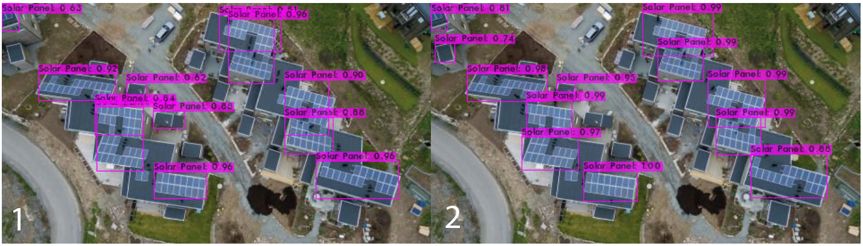

Figure 7, illustration of how model 1 and model 2 detects false solar panel from darkened areas of rooftops.

Model 2 was better on detecting solar panel from images taken from a top-view perspective, i.e. drone footage perpendicular to the ground, see Figure 8 and Figure 9.

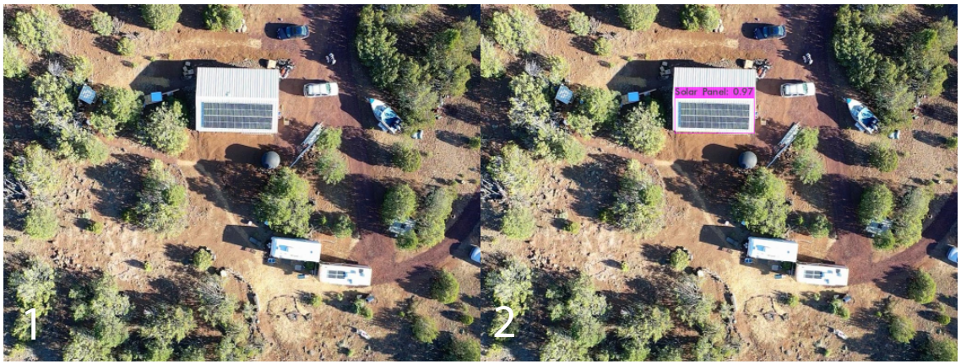

Figure 8, when model 1 missed the solar panel from a top-view perspective when model 2 found it.

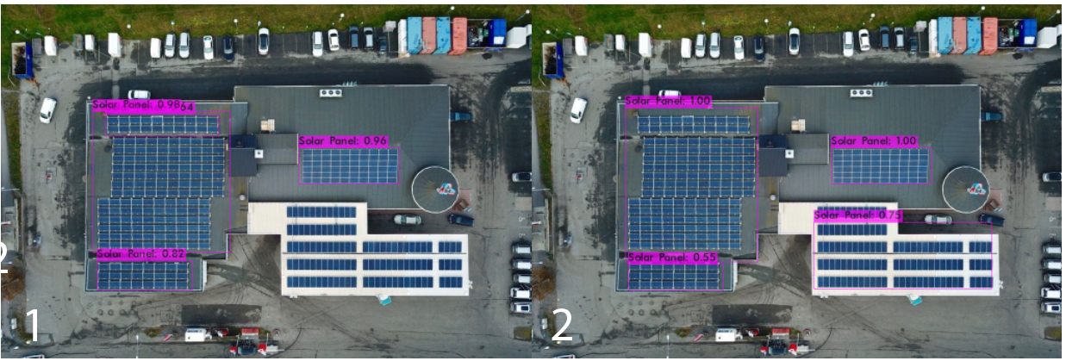

Figure 9, model 2 outperforms model 1 from a top-view perspective of drone footage.

# Discussion

The YoloV4 model is currently one of best architectures to use for object detection. However, a model´s prediction on test images is only as good its quality of good training data. But what constitutes good images for good training data? Most importantly is that the quality of data comes from the information that is contained within the image. For instance, images for a solar panel object detector must include both the properties of the object in question and the spatial orientation of the object in the context of the image. If there were only images of big fields solar panel farms, then the model would have a hard time to see the correlation between the location, size and shapes of solar panels that are on top of rooftops. Furthermore, good data for this case should reflect real drone footage. It is unlikely that drone would need night footage, but how about footage with snow (noise)? If this model would be deployed in production there will be a lot of errors, since the data will be relatively skewed. Also, there are probably inconsistency in the labelling strategy and size of datasets. However, it is hard to know when the datasets size is big enough to allow better generalization, since the shapes and perspective of the solar panel images were very inconsistent.

Gathering and labelling more images is a costly process, since it done through manual labor. Data augmentation makes it easy to get more labeled example without additional labeling and is very effective when applied to images. Even though YoloV4 training pipeline does some augmentation automatically, the rotational augmentation for top view perspective images was deemed as effect approach to generate more training data. However, this process could have oversampled top-view perspective images and increased their weights. Perhaps, augmentations strategies for side-view perspective images should have implemented to balance the dataset distribution. For instance, vertical axis flipping or random cropping could had led to a significantly improved the mAP performance of the model.

The YoloV4 model`s configurations could have been better explored for this project. For instance, larger pixel resolution could improve the overall accuracy and the detection of smaller objects. However, the tradeoff in this case would have been slower training and inference time, which would not really matter. Furthermore, the dataset used during training dissimilar to the COCO-dataset, which includes common objects like people, bikes and cares. It is generally a good idea to start with pre-trained weights. Perhaps, the task to detect varying solar panels was more complex than COCO, which means that it could have been more beneficial to start the training from scratch.

# Conclusion

YoloV4 proved to be a sufficient model to find solar panel from images and videos with various view perspectives. Even though there are a lot of hyperparameters to tune, a significant amount of time should be expected on how to preprocess and validate the data. It is essential because the model is only as good as the data it learn from.

# Refrences

Bochkovskiy, A., Wang, C., & Liao, H. (2020). YOLOv4: Optimal Speed and Accuracy of Object Detection. ArXiv, abs/2004.10934.

Lin, T.-Y., Maire, M., Belongie, S., Bourdev, L., Girshick, R., Hays, J., Perona, P., Ramanan, D., Zitnick, C. L. & Dollár, P. (2014). Microsoft COCO: Common Objects in Context (cite arxiv:1405.0312Comment: 1) updated annotation pipeline description and figures; 2) added new section describing datasets splits; 3) updated author list)